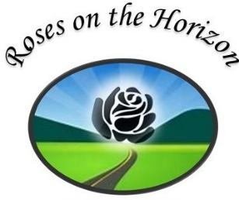
2022 ARS NY District Convention
Hosted by Syracuse Rose Society
September 9-11, 2022

REGISTRATION FORM

Please complete a separate registration form for each person attending the convention. Spouses or other guests may be registered for the Saturday banquet and Sunday breakfast only by completing the appropriate sections below.

Name: ______________________________________________________________________
Nickname for badge____________________________________________________________
Address______________________________________________________________________
City_______________________________________ State___________ Zip________________
Phone________________________Email___________________________________________

Registration on or before August 1 $115 After August 1 $135 $___________

ARRANGEMENT WORKSHOP/JUDGES AUDIT (includes box lunch) $ 30 $___________
Ham_________ Turkey________ Vegetarian________
Saturday awards banquet (included in registration fee)
Sliced Roasted Sirloin ______ Seared Scallop & Shrimp _______ Pasta Primavera _______
Guest only Saturday Banquet $43.00 (ADD MENU CHOICE ABOVE) $___________
Dinner guest name for name tag________________________________
Dietary restrictions?_____________________________________________________________
SUNDAY EDUCATIONAL BREAKFAST (buffet) $25 $___________
Guest Breakfast $25 $___________
Donation-thank you! $___________
Total $___________
Do you plan to exhibit: Horticulture? ______Arrangements? _______Photography?_______
Would you like to Volunteer?_________ Will you be donating a raffle basket?__________
Please make checks payable to Syracuse Rose Society

Please send registration form and check to SRS Treasurer, 107 Cross Rd, Syracuse, NY 13224-2126
For questions please email srstreas@aol.com.

******PLEASE ENCLOSE PROOF OF COVID VACCINATION-REQUIRED WITH REGISTRATION******

Thank you for registering. We look forward to seeing you.

Hotel information (room block available through 8/13/2022; $109 convention rate):

The Collegian Hotel (formerly Genesee Grande), 1060 E. Genesee St., Syracuse, NY 13210
Phone 315-476-4212. Please mention 2022 NY District Convention
or book online at https://www.wyndhamhotels.com/trademark/syracuse-new-york/collegian-hotel/rooms-rates?&checkInDate=09/08/2022&checkOutDate=09/11/2022&groupCode=090922SYR

